SALES PERSONNEL PROCESS IN SYSTEM

1.1) CUSTOMER – DETAILS – INPUT SCREEN

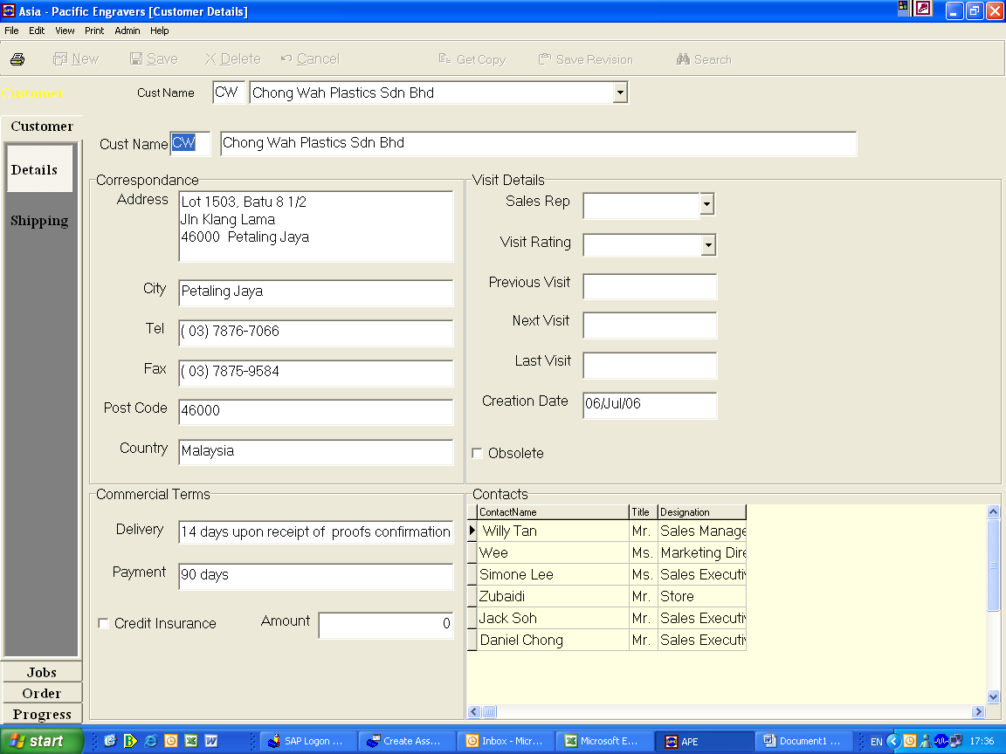

OVERVIEW
To input all customer information such as correspondence, contact details & payment or delivery terms.

RESPONSIBILITY
Respective sales personnel & Finance dept. (Finance dept. only input credit insurance field)

PROCESS PROCEDURE
On screen “Customer – Details”, enter information in the field as specific in the below table.

INPUT REQUIRED FIELD

Field Name | Description | Comments
Cust Name-Field 1 | Customer code | Only 2 alphabetical is allowed.
Cust Name-Field 2 | Customer name
Correspondence | Customer address
Visit Details | Customer visit record for sales personnel | Optional
Obsolete | Tick or un-tick | No use
Commercial Terms | Delivery terms & payment terms
Credit Insurance | Approved limit amount | Conditional
Contacts | Customer contact person

1.2) CUSTOMER – SHIPPING – INPUT SCREEN

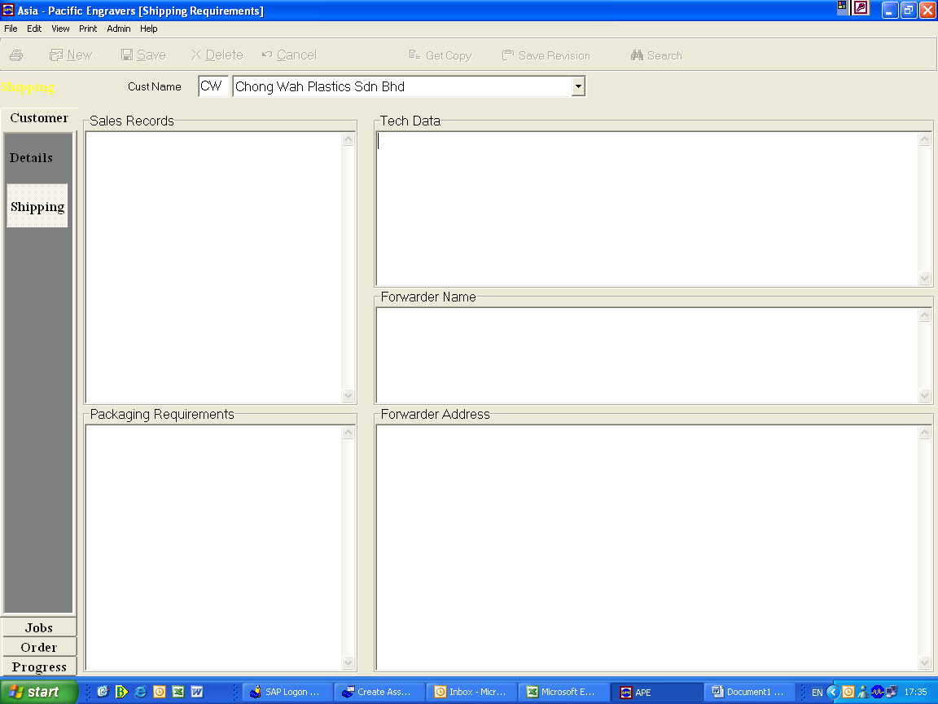

OVERVIEW
To input customers delivery requirement & information.

RESPONSIBILITY
Logistic department – Mr. Prakash

PROCESS PROCEDURE
On screen “Customer – Shipping”, enter information in the field as specific in the below table.

INPUT REQUIRED FIELD

Field Name | Description | Comments
Sales Records |  | Optional
Pkg. Requirements |  | Optional
Tech. Data |  | Optional
Forwarder Name |  | Optional
Forwarder Address |  | Optional

Note : It depends to the logistic whether do they need the information. (In practice, no data was input in this screen for all customers).

